grewardoug@telkomsa.net
3/8/2010

Hi Bruce
I am Doug Grewar now living in Zululand South Africa. I grew up in Zambia and only left when I was 36 years old in 1976, and I am a member of several websites for people who have lived there.

A friend has written a book about her childhood in Northern Rhodesia (now Zambia) and she talks about Matabele ants but gets confused with Red or Driver or Siafu ants. I have been trying to research more on the web to get the latin names of the 2 species. The deeper I go the more confusing it gets.

I found your site http://taos-telecommunity.org/epow/epow-archive/archive_2003/epow-030811.htm but your pictures in my opinion show Siafu ants. I have attached some pics.

We have been discussing the ant story and the following is the input from an Oz friend who grew up in Tanganyika (now Tanzania) and my response to him. Maybe you would like to comment.

Best regards - Doug grewardoug@telkomsa.net

Doug,
This could be the start of another Bucko style ramble!! It all depends on how long you've got!! But I'll try and be reasonable!

From a very early age I have memories of ants in Tanzania! One of my earliest was when at boarding school in Uganda in 1946. I was 5 yrs old. There was a sand pit at the school. I was about the youngest kid in the school. I had a bad habit of wrecking all the carefully constructed roads in the sand pit by pushing my dinky toy trucks or cars too heavily and making wheel ruts that would bog a tractor, never mind the other kids dinky toys. A French kid, Claude Felts, who came over from Burundi and was bigger than most of us, got really pissed off so he told me I could not play in the sand pit. After a huge protest on my part, it was agreed that if I stood in a trail of siafu ants, without any shoes on, until I was told to get out, I could play. Needless to say, I was used to fair play, and didn't see the obvious.

The ants quickly decided to eliminate this blockage to their trail. But just to make sure they were seriously razzed up, a few kids got sticks and stirred up the line as well. I managed to stand there until my daks were inundated with ants, but once the bites were aimed at the softer bits inside my daks, I tried pleading for mercy, but had to give up!! However, the teachers finally enabled my return to the pit, and I learnt the lesson to keep my trucks under control!!

We also had major invasions at times from the safari ants. They were the longer, bigger black ants that moved in a phalanx about 10 to a dozen ants wide, and they moved fast compared to the siafu. Those black safari ants were not to be messed with. Put a stick into their lines, and they'd come at you from all sides and even chase you. Their sting was enough to send a little kid hopping and hollering like a castrated pig. Just one sting was enough! They were brilliant at cleaning up vermin.

I remember one time we had a plague of cockroaches in this old German built house we lived in near Kigoma. One night a few armies of these 'masalasa' or safari ants came through. We all leapt into our beds and sat tight. By the morning the ants were gone and not a coacroach was to be seen!

My other enjoyment of ants in Tanazania was just after the rains broke. The white ants took this as their time to breed, and the nuptial flights of hundreds and hundreds of ants occured. The Africans dug holes at the end of a nest, built a small roof over the nest and the hole. They placed a garter of banana palm strippings around the mouth of the hole, making it overlap the edges. The flying white ants would take off from the mound, hit the roof, fall and roll into the hole. The garter prevented them getting out.

My method was much less sophisticated. I hit them with a tennis racquet while in flight, then put them in an enamel bowl. They couldn't get a grip on the enamel and were stuck there. There were two ways of enjoying these ants. One was to grab the wings and then quickly put the struggling ant in your mouth and chew. I never got bitten once. The flavour is a mixture of a butter like substance on your tongue with a slight nutty flavour. The legs and outer layer, the exoskeleton, left bits of stick like remains in your mouth, after gorging on a pile of these ants. The other way was to lay them out on the top of the wood burning stove that we cooked on, and heated all our water for baths on. I'd pull off their wings and roll the ants over a bit, often they would pop their abdomens from the heat, but they tasted much better cooked than raw.

But the best way to eat them was to thread them on a sliver of elephant grass. Probably 20 or 30 on one sliver. these were then smoked over a fire until a shiny brown coat covered them. That was really good!! I can remember when out hunting, I dropped in on a local beehive hut in a banana plantation above our house. the locals welcomed me and I was asked to 'keti muda kidogo' (sit for a while). They brought me an old Kenya Creamery Butter tin (probably from our rubbish), filled with smoked white ants. We sat and ate them and drank milk that had curdled and gone sour. It was of course unboiled, unpastuerised, but in those days, I was blissfully ignorant and never had any problems afterwards! These white ants were called 'nchwa', in swahili.

Doug, have you ever drunk their 'pombe', the beer they make from crushing ripe bananas with their feet in a wooden canoe like hollowed out tree trunk? This is left to ferment and decanted into earthen ware jars. You'd pay 10c for a drink, grab a straw of grass already in the jar, and suck like hell until the trader flicked the straw out of your mouth, and the next guy took over. After these market day drinking sessions the drunken fights would start. My mom had the task of trying to repair the gashes and broken limbs from pangas and even axes. She was no medico, and only had first aid treatments available, but that is all those poor blighters got. They never went to hospital as it was 5 miles away on foot, and they'd often wait all day to be treated at all.

Cheers, Bucko

Bucko
Thanks for that interesting response.
I would just like to clarify the difference between the bigger +/- 2.5cm black ants that we used to call Matabele ants and the smaller up to 2cm Red ants.
It seems to me that the ones you describe as Siafu ants are our Red ants or Driver ants (Dorylus nigricans) that attack by biting with their nippers and once they have a hold never let go. They move in bunches and can cross small streams by forming a bridge with their bodies. When they trek you often find the ones along the edge holding one another forming a sort of stationary hedge on both sides of the central path along which pour the others. They come in various sizes but always mixed among them are the ones with the big nippers who must be the soldiers. They do not make any noticable noise or give off any noticable smell. I have read that the Masai Moran use them to suture wounds together by picking up the ant, then squeezing the two sides of the wound together and pushed the ant's head against against them and when its jaws had clamped tight they would nip off its head with their nails. The head would remain it place like a shiny brick red bead. We used to do the same thing as a decoration around our hat brims at Gilbert Rennie Boys High School in Lusaka. See:
http://www.bbc.co.uk/nature/wildfacts/factfiles/3086.shtml
http://www.blessedquietness.com/yarn/pinching.htm
http://www.economicexpert.com/a/Safari:Ant.html
Then the ones that you call Safari ants with the fearsome sting seem to be our Matabele ants. You say: We also had major invasions at times from the safari ants. They were the longer, bigger black ants that moved in a phalanx about 10 to a dozen ants wide, and they moved fast compared to the siafu. Those black safari ants were not to be messed with. Put a stick into their lines, and they'd come at you from all sides and even chase you. Their sting was enough to send a little kid hopping and hollering like a castrated pig. Just one sting was enough! This is a perfect description of Matabele Ants. Matabeles also when you poked their lines with a stick or quickly stamped on them would hiss and give of a warning sharp smelling scent.
Many websites seem to mix up the Safari (Matabele?) with Driver or Siafu ants. See:
http://taos-telecommunity.org/epow/epow-archive/archive_2003/epow-030811.htm
For me these pictures are of Siafu pinching ants. But are refered to as Matabele ants. I have emailed Dr Bruce G. Marcot to see what he says about this.
Regards - Doug

matabele ants.jpg
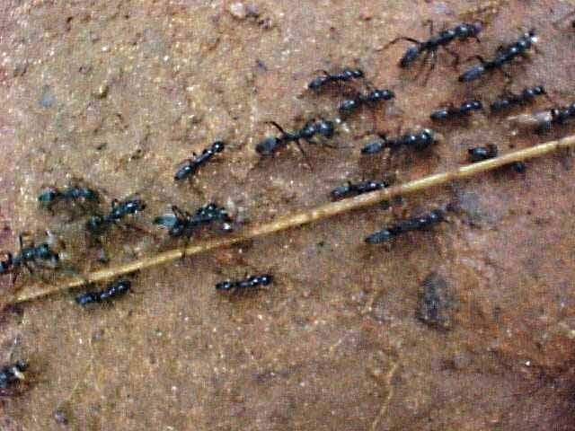

Red, Driver or Siafu ants.jpg
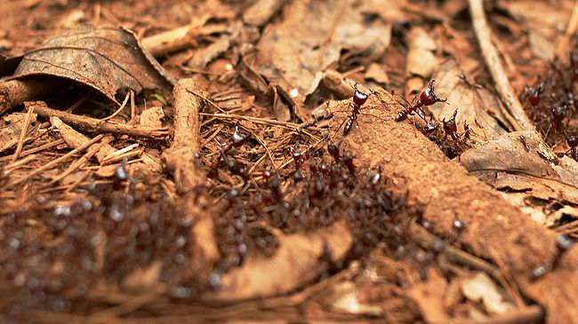

red ants.jpg
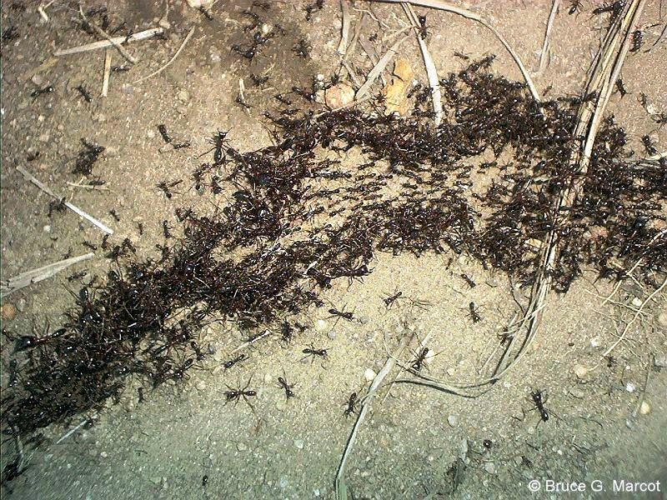
grewardoug@telkomsa.net
3/9/2010

Both Red Siafu and Black Matabele ants seem to be referred to as Safari ants.

Red or Driver Ants (kiSwahili = Siafu) (Dorylus nigricans?)
Red ants or Driver ants (Dorylus nigricans) attack by biting with their nippers and once they have a hold never let go. They do not sting. They move in bunches and can cross small streams by forming a bridge with their bodies. They only travel at around 20 meters per hour and so can be easily avoided. When they trek in columns of up to 50 million you often find the ones along the edge holding one another forming a sort of stationary hedge on both sides of the central path along which the others march. Sometimes this is referred to as a tunnel. When they reach the hunting grounds they spread out over a broad front. They come in various sizes up to about 15mm but always mixed among them are the soldiers with the big nippers. They do not make any noticeable noise or give off any noticeable smell.
Male driver ants, sometimes known as "sausage flies" (a term also applied to males of New World ecitonines) due to their bloated, sausage-like abdomens, are the largest known ants, and were originally believed to be members of a different species. Males leave the colony soon after hatching, but are drawn to the scent trail left by a column of Siafu once it reaches sexual maturity. When a colony of driver ants encounters a male, they tear its wings off and carry it back to the nest to be mated with a virgin queen. As with all ants, the males die shortly afterward.
I have read that the Masai morans use them to suture wounds together by picking up the ant, then squeezing the two sides of the wound together and pushed the ant's head against them and when its jaws had clamped tight they would nip off its head with their nails. The head would remain it place like a shiny brick red bead. We used to do the same thing as a decoration around our hat brims at school in Lusaka. Siafu will eat anything in their path from cockroaches to snakes to humans. See:
http://www.bbc.co.uk/nature/wildfacts/factfiles/3086.shtml
http://www.blessedquietness.com/yarn/pinching.htm
http://www.economicexpert.com/a/Safari:Ant.html
http://www.serengeti.org/flying_ant.html
http://en.wikipedia.org/wiki/Siafu

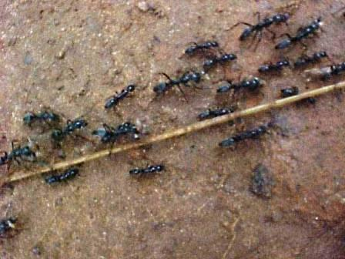
Matabele Ants (kiSwahili = Masalasa) (Megaponera foetens) (Pachycondyla analis)
These black ants are longer and bigger than Siafu (about 25mm). They move in a phalanx about 10 to a dozen ants wide, and not more than 100 or 200 in a regiment. They move fast compared to the Siafu and separately from one another not all bunched up like the Siafu. Those black safari ants are not to be messed with because their sting is extremely painful. If you poke their lines with a stick or quickly stamp on them they will hiss angrily and give of a sharp smelling scent as a warning and they will come at you and even chase you for a short distance.
http://wilderness-safaris.co.za/news/camp_news_detail.jsp?newsItem=5528
http://www.britannica.com/EBchecked/topic-art/171712/122295/Driver-ant-attacking-a-much-larger-Matabele-ant
This last site gives an excellent picture that supports exactly what I have been trying to say.
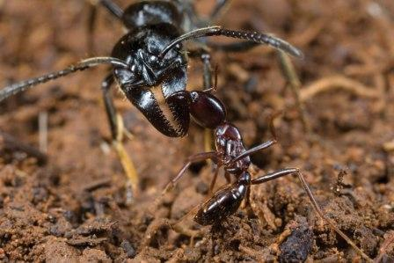

3/27/2010:

Bruce
I have now found the chiBemba names for Red driver ants is impashi and the larger black Matabele ants is iminangu. Bemba is the major language in Zambia although in the Luangwa valley area, where you visited, chiNyanja would be common.

Regards - Doug

